CONCEPTS
EMBEDDING PIPELINE-how text gets converted into vector
Step 1: Tokenization
First, the text gets broken into tokens (not words, tokens).
"i love u" → ["i", "love", "u"]
Simple here, but something like "unbelievable" might become ["un", "##believable"]. Each token gets mapped to an integer ID from the model's vocabulary:
["i", "love", "u"] → [1045, 2293, 1057]
Wether the tokens will be words,characters is decided by the tokenizer algorithm of the embedding model. The training data frequency decides. The tokenizer is trained separately before the main model, on a large corpus. It just counts:
"what substrings appear so often that they deserve their own token?"
Common words like "love", "the", "is" → get their own single token
Rare or long words like "unbelievable" → get split
Very rare stuff → split down to individual characters or bytes

Step 2: Token Embeddings (first smaller vectors)
Each token ID gets looked up in an embedding table — basically a giant matrix the model learned during training. Each token gets its own vector, say 768 numbers.
1045 ("i") → [0.21, -0.43, 0.87, ...] ← 768 numbers
2293 ("love") → [0.95, 0.11, 0.33, ...] ← 768 numbers
1057 ("u") → [0.44, -0.22, 0.61, ...] ← 768 numbers
So right now you have 3 separate vectors, one per token.

Step 3: Transformer layers process them together
This is the magic part. The transformer runs attention — every token looks at every other token and updates its own vector based on context.
So "love" now sees "i" and "u" around it. The vector for "love" shifts based on that context. This is why:
- "I love you" → warm/emotional meaning
- "I love Python" → enthusiasm/interest meaning
Same word "love", but different final vector because context changes it.

Step 4: Pooling — collapse 3 vectors into 1
After the transformer, you still have 3 vectors (one per token). But you need one single vector for the whole sentence.
Most models do mean pooling — just average them:
final_vector = mean([vec_i, vec_love, vec_u])
= one vector of 768 numbers
Some use the [CLS] token (a special token prepended to every input that's trained to summarize the whole sentence).

Final output
"i love u" → [0.61, -0.18, 0.74, 0.09, -0.55, ...] ← 768 numbers
And now here's the cool part — if you do the same for:
"i love you" → [0.63, -0.17, 0.71, 0.11, -0.52, ...]
"I adore you" → [0.59, -0.20, 0.69, 0.08, -0.57, ...]
"i hate you" → [-0.41, 0.88, -0.23, 0.67, 0.34, ...]
The first three will be very close in 768D space. The last one will be far away. That's the whole point — meaning is preserved in the geometry.

VECTOR DB
The problem without a vector DB
Say you've embedded 1 million documents. Each is a 768-dim vector. A user types a query, you embed that too. Now you need to find the top 5 most similar vectors out of 1 million.
Brute force approach: compare your query vector against all 1 million vectors one by one using cosine similarity.
That's 1 million dot products every single query. Slow as hell at scale.

What a Vector DB does
A vector DB stores your vectors and builds smart index structures so you can find the nearest neighbors fast — without comparing against every single entry.
Query: "i love u" → embed → [0.61, -0.18, 0.74, ...]
↓
Vector DB finds top-5 closest
vectors in milliseconds
↓
Returns the original documents back
It's like a regular DB index, but for geometric closeness instead of exact matches.

The algorithm behind it — HNSW
Most vector DBs use something called HNSW (Hierarchical Navigable Small World). Don't stress the name — the idea is:
- Build a graph where each vector is connected to its nearest neighbors
- At query time, navigate the graph greedily toward the answer
- You never check all 1M vectors — you hop through the graph and converge fast
Approximate, not exact — but 99%+ accurate and orders of magnitude faster.

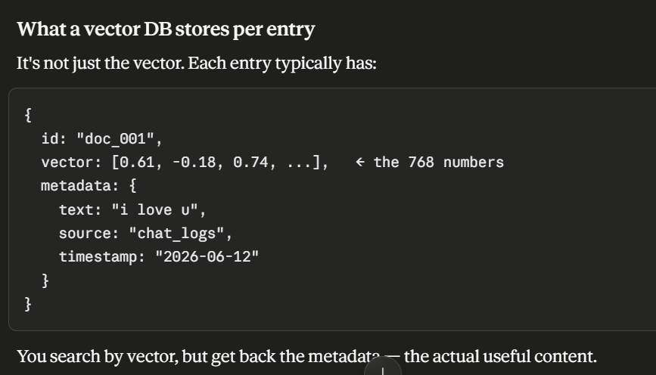

MEMORY ARCHITECHTURE
Grace Memory Architecture: The Three Verticals
This document outlines the three distinct layers of memory that govern how Grace understands, retains, and retrieves context during conversations.
Understanding the hard boundaries between these three verticals is crucial for debugging context-loss issues and building advanced agentic workflows.

Vertical 1: The Base LLM (Stateless & Frozen)
The core engine powering Grace is the Gemini API. It is critical to understand that the raw API is 100% stateless.
How it works:
- Pre-trained Knowledge: Gemini possesses vast internal knowledge (how to write Python, what AWS is, general human history) baked into its neural network weights during Google's training phase.
- Frozen State: Gemini cannot "learn" new permanent facts just by talking to it. Its neural weights do not update after a conversation.
- Stateless Requests: Every single HTTP request to the Gemini API is treated as an isolated, independent event. If you send "Hi, my name is Prashant" and then send "What is my name?" 5 seconds later in a new request, it will not know your name.
WARNING
The SDK Illusion: The @google/genai SDK provides a chat.sendMessage() method that appears stateful. Under the hood, the SDK simply stores the chat history in the Node.js server's RAM and re-sends the entire massive text array to Google's stateless servers on every single call. If the Node.js server restarts, the SDK's RAM is wiped, and all memory is lost.

Vertical 2: Short-Term Memory (DynamoDB Context Window)
Because the API is stateless and the SDK's RAM is volatile, Grace requires an external, persistent Short-Term Memory. This is implemented via the GraceChatSessions table in DynamoDB.
How it works:
- Persistence: Every message sent by the user and generated by Grace is instantly saved to DynamoDB.
- The 50-Message Buffer: When you speak to Grace, the backend queries DynamoDB for the last 50 messages of the current session.
- Context Injection: The backend packages those 50 messages into an array and feeds them into Gemini's "Context Window" along with your new prompt.
The Limitation:
This acts as Grace's "Working Memory." It allows her to follow the immediate thread of conversation perfectly. However, once a message becomes the 51st oldest message, it is dropped from the payload. Gemini can no longer "see" it, and Grace will completely forget it happened.

Vertical 3: Long-Term Memory (Pinecone RAG Pipeline)
To solve the limitation of the 50-message buffer, we use Retrieval-Augmented Generation (RAG) via Pinecone. This acts as Grace's permanent, long-term memory.
How it works:
RAG operates in two asynchronous phases: The Indexer and The Retriever.
The Indexer (Writing Memory)
When a conversation reaches a milestone or a session ends, a background process evaluates the chat.
- Extraction: It extracts concrete life events, preferences, or decisions (e.g., "Prashant hates cold showers but does them anyway", "Prashant is studying for an AWS exam").
- Vectorization: It passes these text chunks to text-embedding-004 to generate a mathematical vector array (768 dimensions).
- Storage: It uploads the vector, alongside the raw text as metadata, to Pinecone.
The Retriever (Reading Memory)
When you ask a question months later:
- Query Embedding: Your question is vectorized.
- Similarity Search: The backend queries Pinecone for the Top 5 mathematically similar vectors from the past.
- Augmentation: Pinecone returns the raw text facts. The backend secretly injects those facts into Grace's systemInstruction before sending the payload to the stateless Gemini API.
NOTE
The Result: Even though the conversation happened 6 months ago and is no longer in DynamoDB, the Retriever sneaks the historical fact into the current payload, allowing Grace to organically reference past events as if she never forgot them.

